

YOUR LOGO HERE

Web Mail Guide

March 2011

Powered by


Web Mail Guide 1
1 Introduction to Web Mail 2
1.1 Requirements 2
1.2 Recommendations for using Web Mail 2
1.3 Accessing your Web Mail 2
1.4 Enabling and Disabling Web Mail 2
2 Your Web Mail Home Page 2
2.1 Navigation Pane 2
2.2 Usage Summary 2
3 Using the Inbox 2
3.1 Resizing Columns and Panes 2
3.2 Moving messages 2
3.3 Selecting a message 2
3.4 Sorting messages 2
3.5 Reading a message 2
3.6 Replying to a message 2
3.7 Replying to All 2
3.8 Forwarding a message 2
3.9 Printing a message 2
3.10 Deleting Messages 2
3.11 Checking External Mail 2
4 Creating a Message 2
4.1 Sending Messages 2
4.2 Creating Drafts 2
4.3 Canceling a message 2
4.4 Sending a file with a message 2
4.4.1 Attach a file 2
4.4.2 Sharing a file 2
5 Address Book 2
5.1 Accessing your Address Book 2
5.2 Selecting an Address Book 2
5.3 Searching the Address Book 2
5.4 Sorting the address book 2
5.5 Adding a New Contact 2
5.5.1 Adding New Contact Information 2
5.5.2 Adding Contacts after Sending a Message 2
5.6 Adding a New Group 2
5.7 Importing Contacts 2
5.8 Editing a Contact 2
5.9 Deleting a Contact 2
5.10 Sending Mail to a contact 2
6 Web Mail Folders 2
6.1 Managing Folders 2
6.1.1 Creating Folders 2
6.1.2 Renaming a Folder 2
6.1.3 Moving a Folder 2
6.1.4 Deleting a Folder 2
6.1.5 Emptying a Folder 2
6.1.6 Changing Folder Properties 2
7 Searching for Messages 2
8 Viewing Web Mail Options 2
8.1 Your Information 2
8.2 Mail Handling 2
8.2.1 E-mail Forwarding 2
8.2.2 Auto Response 2
8.2.3 Check External Mail 2
8.2.4 E-mail Rules 2
8.2.5 E-mail Notification 2
8.2.6 SpamShield Pro 2
8.3 Additional Options 2
8.3.1 Signature 2
8.3.2 Preferences 2
9 Using Web Calendar 2
9.1 Scheduling Events 2
9.1.1 Moving Events 2
10 Support 2

Introduction to Web Mail
With functionality similar to desktop e-mail applications, Web Mail provides a rich experience to instantly access your e-mail, calendar, contacts, and one_storage files. We hope you find this guide useful. If you have any questions, please contact OTEC Communication Company’s Tech Support at 888-232-7930.

  - Requirements
Web Mail works best with the following system configuration:
- A laptop or desktop computer manufactured within the last 3 years
- The latest version of Adobe Flash Player (for advanced file attachment handling)
- The latest version of one these supported browsers (with JavaScript and cookies enabled)
  - Internet Explorer
  - Firefox
  - Safari
  - Chrome
- A 56 Kbps Internet connection or faster

  - Recommendations for using Web Mail
- Always enable pop-ups from the Everyone.net site because some options, such as Printing, appear in a new browser window. You’ll also need to enable pop-ups to save a message to your computer. Just go to your browser and in the Tools menu, click the option to enable pop-ups.

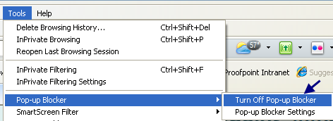

- Web Mail performance is influenced by your computer’s CPU speed (often measured in GHz) more so than the speed of your Internet connection. If Web Mail runs slowly on your computer, you can switch to Classic Web Mail. However, you should be aware that you will lose access to some functionality, such as one_storage.
  - Accessing your Web Mail
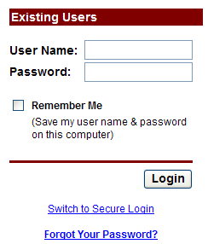 | To login to your e-mail account:  - Go to your Web Mail login page.  - Enter your username (first portion of your e-mail address, before the @).  - Enter your password.  - Click Login.  Checking Remember Me saves your user name and password on your computer. Do not select this feature when accessing your account from a public computer.

  - Enabling and Disabling Web Mail
You can easily enable and disable the Web Mail interface at any time.

To enable Web Mail:
- Click Options. (This link is located in the upper-right-hand corner to the left of the Help and Logout links.)
- Click Preferences.
- Scroll down to Web Interface and select the radio button for “Yes, enable the new features.” as shown below.

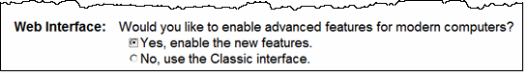

To disable Web Mail:
- Select Options.
- Select Preferences.
- Scroll down to Web Interface and select “No, use the Classic interface.”

Your Web Mail Home Page
The Home page opens when you log into your Web Mail account. Initially, you’ll see two main sections:
- Navigation Pane
- Usage Summary

If you need to get back to the Home page while you’re using Web Mail, just click the Home link located on the upper right section of Web Mail.

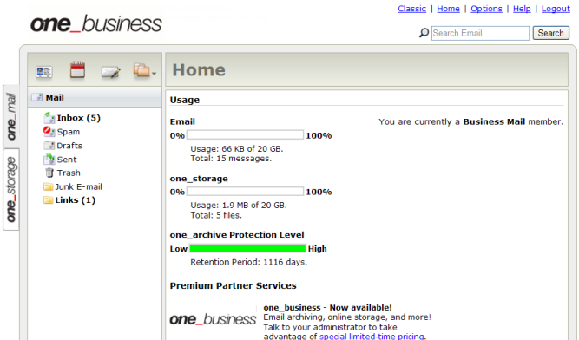

Web Mail Home Page

Navigation Pane
The Navigation Pane shows icons that you use to access your address book, view your calendar, write a new message, and apply folder actions. It also lists all of your Web Mail folders such as Mail, Contacts, and so on.
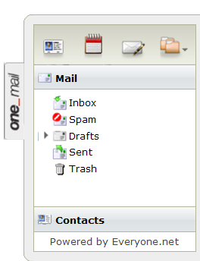

Mail Folders
The standard system folders (Inbox, Spam, Drafts, Sent, and Trash) are shown above. You can add your own folders and subfolders. Folders that you add can be renamed, moved, and deleted. These functions are described in the section titled Web Mail Folders.

Note: System folders are not changeable by using the Folder Actions menu.

Viewing Folder Contents
When you click a folder in the Navigation pane, that folder’s contents will appear in this area of the Home page. This is where your e-mail will appear.

Usage Summary
The Usage Summary provides information about your storage capacity, and your account status.
Announcements
Information and messages from your administrator may occasionally appear below the Usage section.

Using the Inbox
Click the Inbox folder to see all new mail, except for e-mail being filtered by SpamShield or E-mail Rules. The picture below shows the inbox with the Reading Pane visible.
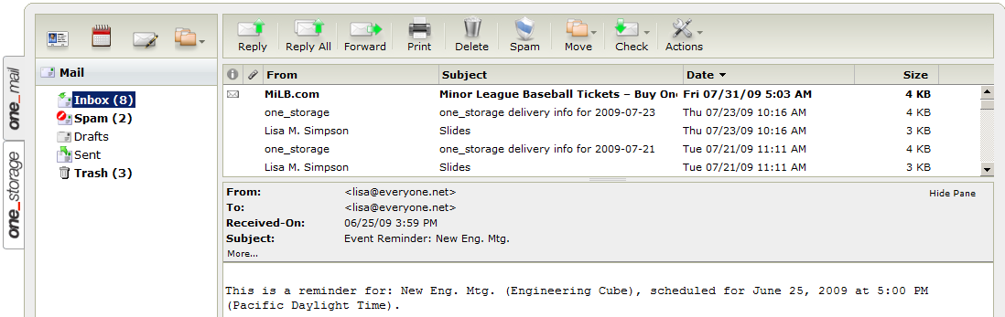
Web Mail Inbox with Reading Pane

Resizing Columns and Panes
You can change the width of the From, Subject, Date Received, and Size columns. Using the same technique, you can change the width of the Navigation Pane and adjust the height of the Reading Pane.
To change column width:
- Move the mouse pointer over the column border until the double-headed arrow appears.
- Click the left mouse button and drag the double-headed arrow left to decrease and right to increase the width of the column.
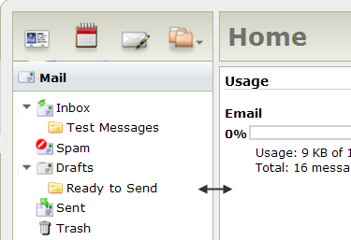

To change the size of the Reading Pane:
- Move the mouse pointer over the column border until the double-headed arrow appears.
- Click the left mouse button and drag the double-headed arrow up to increase and down to decrease the height of the Reading Pane.

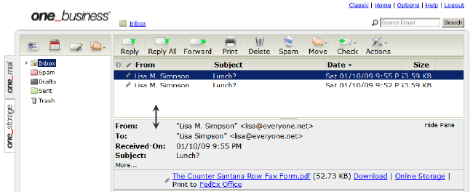
Changing the height of the Reading Pane

Moving messages
You can move messages in two ways. You can use the Move menu or simply drag the message to a new location.
To use the Move menu:
- Select the message you want to move.
- In the Web Mail toolbar, click Move to display the list of folders.
- Select a destination folder and click.

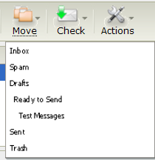

To drag-and-drop a message:
- Display the contents of the folder that contains your message.
- Select the message.
- Drag the message to the desired location or folder.
- Drop the message by releasing the button.

Note: The message will indicate whether the location is valid or invalid.

Selecting a message
As in other e-mail programs, you can select one or several messages and then move or delete them.
To select or deselect a group of messages:
- Press the Shift key and select the first message in the group.
- Without releasing the Shift key, select the last message in the group.
- Move or delete the group of messages.

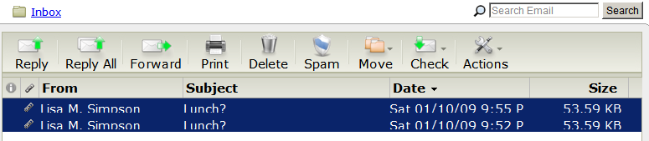
Selecting a Group of Messages

To select discontinuous messages:
- Select the first message and click the Ctrl key.
- Without releasing the Ctrl key, select the next messages.
- Release the Ctrl key once you are finished selecting all desired messages.
- Move or delete the selected messages.
Note: Mac users should use the Command key instead of the Ctrl key.

Sorting messages
Messages in a folder can be sorted by the sender name, subject, date and time, or the size of the message.
To change the sort order of messages in a folder:
- Click the column header.

Reading a message
You can read text messages or files in Web Mail. You can also forward or reply to received e-mails. Any of the attachments in the original mail may be attached or inserted inline to a forwarded e-mail.
- Click a message to preview it if the Reading Pane is open.
or
- Double-click on a message to open it if the Reading Pane is hidden.

This picture below shows the header portion of an open e-mail with an attachment.

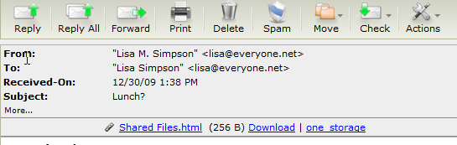

Fields in the e-mail header are:

From | Contains the sender’s name and e-mail address.
To | Displays the name and e-mail addresses of the recipients.
Cc | Lists recipients who received a copy of the message.
Subject | Describes the subject of the message if the sender specified one.
More/Less | Clicking More displays more headers and information about the message. Hide this information by clicking Less.
Attachments | If you received an attachment with your message it will be displayed in this section. Here you can select Download to save this attachment to your computer: In addition, you can save to one_storage if available.  To View or Open the Attachment, click the file attachment’s name. A new browser will open displaying the document  To Download the Attachment, select the Save link next to the attachment name.  To save to one_storage:  - Click the one_storage link.  - Choose where to save the file.
External Images | Externally-hosted messages might be hidden and appear as a broken image. A yellow info banner will display above the message when external images have been blocked. Click Load External Images to view these images.  Web Mail hides externally hosted images by default to protect you from web bugs used to track your activity, and accidental exposure to undesired content.  Choose View Options in the yellow info banner to specify how Web Mail behaves when it encounters a hosted image.

Replying to a message
Select a message and click Reply.

Replying to All
Select a message and click Reply All.

Forwarding a message
By default, forwarded messages are sent as attachments and show just below the subject line of your message.

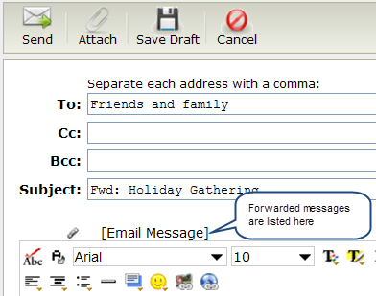

To forward a message:
- With the message selected, click Forward.
- Enter the e-mail address of your recipient in the To: field. At least one e-mail address is required.
- Click Send.
However, you can change the default behavior and have your forwarded messages sent inline with the new message.
To change your Preferences:
- In the upper right corner of the Web Mail page, click the Options link.
- Under Additional Options, click Preferences.
- Click the radio button to have your messages forwarded inline.
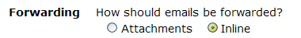

Printing a message
We recommend you always allow pop-ups from our site because Printer View opens in a new browser window.
Note: The print option of your browser may not print the entire message.

To print a message:
- Select the desired message.
- Select Print from the menu.
- When the new browser opens, click Print.

Deleting Messages
If your account reaches the maximum storage quota limit, you will not be able to receive new messages. You will receive a quota warning message when you near your storage limit.
- Select the desired message or messages.
- Select Delete from the menu.

To permanently delete e-mails from the Trash folder:
  - Select the Trash folder.
  - Click the Folder Actions icon.
  - Select Empty Folder. This action permanently removes all messages from the Trash folder.

Checking External Mail
You can check messages from other e-mail addresses using your Web Mail. For more information about the programs you can access, review Check External Mail later in this guide.

The Actions Menu
This menu contains several message actions that can be applied to one or (in some cases) more e-mail messages.

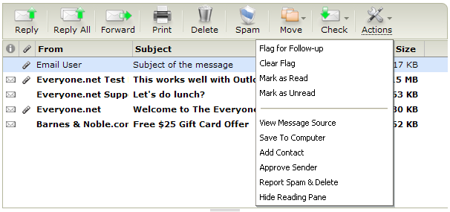

Flagging a message for Follow-up
Adding a flag to a message simply provides a reminder to you or the recipient that something needs attention or should be tracked. To remove the flag, just select the message and click Clear Flag.
Marking messages as read
You might use this to reduce the number of unread messages in your folder but still keep the message.
Viewing the Message Source
Using this menu item shows you detailed information about the message, its format, type, and so on.
Saving a message to your computer
Select this menu item to save a message to your computer. You’ll need to respond to the standard File Download Security message and specify the location for the message.
Note: Make sure you have pop-ups enabled so that you can use this option.

Adding a Contact
This feature is available when a single message is selected
- Select a single message.
- Select Add Contact.
Approving Sender(s)
- Select the desired message.
- Select Approve Sender.
Reporting messages as spam & deleting them
This will automatically report the message as Spam and move it to the trash or Spam folder
Showing and hiding Reading Pane
- Select Show Reading Pane to view the message of a selected e-mail without opening the e-mail message.
- Select Hide Reading Pane to hide the body of e-mail messages from within the Inbox.

Creating a Message
In the Navigation Pane, click the Compose icon to open a new message window.

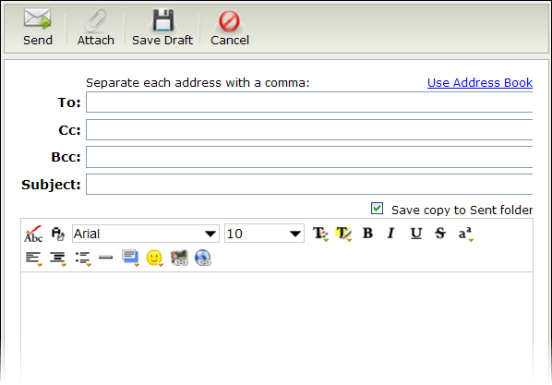

The following table highlights some of the fields and features available when you compose a message. By default, auto-save draft saves messages every minute but you can change this preference.

Use Address Book  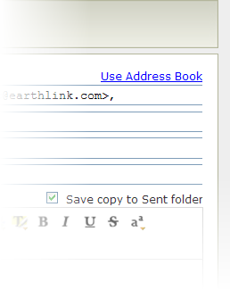 | You can use the Address Book to find names, e-mail addresses, and groups.  - While on the compose page, click Use Address Book to display your contacts. Either use Find or select the first letter of either name to find the contact or group.  - Click To, Cc, or Bcc to place the contact name in the correct field.  - Compose your e-mail message, and then click Send.
Add Contacts  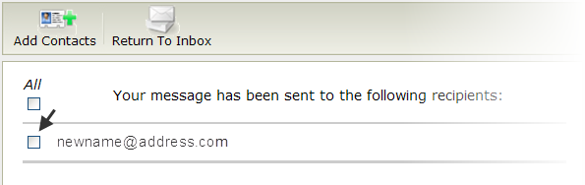 | If you enter an e-mail address not currently in your Address Book:  - After clicking the Send Message button, click the box next to each recipient you want to add or click All.  - Then click Add Contacts.  - Click Return To Inbox.
Save copy to Sent folder | Check the box next to Save Copy if you wish to save a copy of the e-mail message in your Sent Folder.
Spell Check  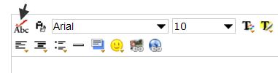 | Check the spelling of the message you’re writing by clicking this icon. Click any highlighted words to see a list of suggested corrections.
Plain/Rich Text  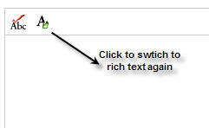 | This feature allows you to change the formatting of the message from Rich Text to Plain Text and vice-versa.  Note: All formatting changes will be lost when you switch from Rich to Plain text.
Emoticon  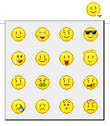 | Use an emoticon in your message:  - Move your cursor to the location where you would like to place your emoticon.  - Click the Emoticon button.  - Select the image.
Link Image  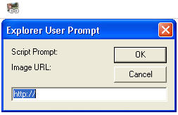 | This feature allows you enter images which are found on the internet.  To insert pictures as embedded images:  - Click the Link Image button  - Enter the location of the image which must be available online.  - Click OK
Link URL  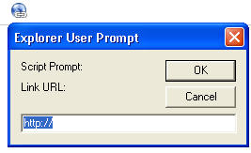 | This feature allows you to link selected text to a website.  To add a link:  - Type the word(s) you will be linking to the URL  - Select the word(s) by highlighting these  - Click the Link URL button  - Enter the URL  - Click OK

Sending Messages
To send a message:
- Ensure you have enter the e-mail address of your recipient in the To field. At least one e-mail address is required.
- Click Send.
A confirmation message appears notifying you that your message was sent.

To Save All Sent Messages to your Sent Folder
- On the left of the page, click the Options link.
- Under the Additional Options button, click the Preferences link.
- Next to the Save Sent Messages setting, choose the Yes and then click Save.

Creating Drafts
Saving a message as a draft allows you to compose a message and return to it later without sending. By default your auto-save draft option will save messages every minute.

To save a message as a draft:

- Click Save Draft.

To retrieve the draft message:
- Click Mail to display the list of folders.
- Select the Drafts folder.
- Find the message and add more text, correct the contents, or send the message.

Canceling a message
Once a message has been sent you can not stop the delivery. However, you can click Cancel any time before you send it.

Sending a file with a message
Web mail has two ways to send a file over the Internet. You may see one or both buttons depending upon your account.

Attach a file
Use Attach to send files or pictures with e-mail messages. Attachments can be text documents, spreadsheets, graphics, photographs, or sound files.

To Send an Attachment:
- Click the Compose icon to open the window for writing a new e-mail.
- Select a file from the file browser window, and click Open.
- The file you selected appears below the subject field.
Note: You can send up to 25 MB of attachments per e-mail, either as a single file or group of smaller files.

Sharing a file
Use Share to send files with e-mail messages and upload the file to your one_storage service.

To share a file:
- Click the Compose icon to open the window for writing a new e-mail.
- Click Share and choose whether to share from the computer or from one_storage.
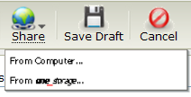
If you choose to share from the computer, a window appears so you can browse for the file.
- Click Open to add the file to your message.
or
If you choose to share from one_storage, the window that appears contains all of the files you have stored there.
- Select one or several files and then click Close.
Note: You can share up to a 1 GB (1,000 MB) file from your one_storage service.

Address Book
In your Address Book you’ll find the contact details, such as e-mail addresses, names, and phone numbers. All services come with the default Personal Address Book.

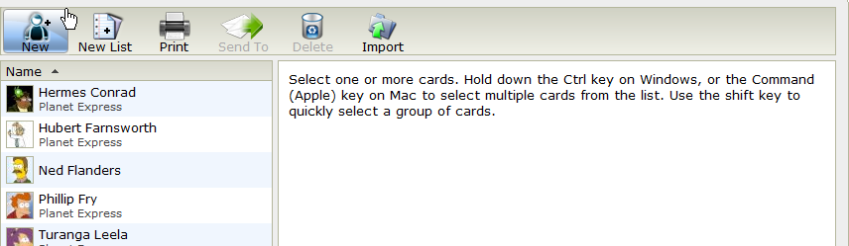Address Book Page

Accessing your Address Book
Click the Contacts icon at the top of the Navigation Pane or click the Contacts tab.
.
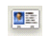 | or | 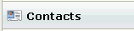

Selecting an Address Book
Your Address Book has two sections, Personal and Shared Contacts. Personal contacts are contacts you add. These contacts can be changed and modified at any time. Shared Contacts can be changed and modified only by your Web Mail administrator.

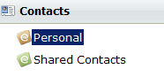

Searching the Address Book
The Address Book can be searched by:

- First Name
- Last Name
- E-mail Address

Just select the folder or subfolder you want to search and enter a first name, last name or e-mail address.

Sorting the address book
The Address Book uses standard sorting with an upward pointing arrow indicating that the names are sorted in ascending order of first name, last name, or e-mail address. Clicking the column header resorts the list of last names in descending order. If there is no name, then the e-mail address is displayed, and will sort by that first.

Adding a New Contact
In the Address Book, click New to open the new contact screen.

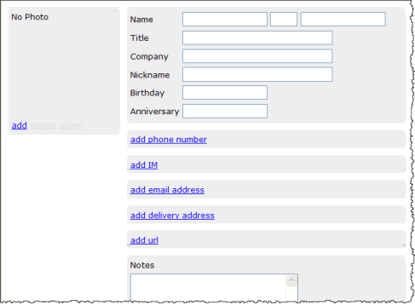

Adding New Contact Information
About adding the e-mail address:
- Click the link to add an e-mail address.
- Select the type of contact from the drop-down list.

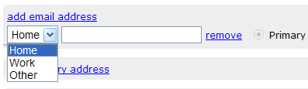

- Enter the e-mail address in the field provided. (This is the primary address for a new contact).
- Repeat if you want to add a second e-mail address, but be aware that the first e-mail is still considered the “primary” e-mail address.
Note: If no e-mail address is entered, the Auto Complete preference will not recognize this contact when composing a message.

Entering the Name information
Be sure to complete the Name fields so that search can find this contact.

Add a Photo (optional)
You can attach a photo by clicking the Add link.

Add a phone number
- Click the “add phone number” link.
- Select the type of phone number and enter it in the field provided.
- Repeat if you want to add more numbers.

Add an instant message ID
- Click the “add IM entry” link
- Select the type of IM service from the drop-down list.
- Enter your screen name for that service.
- Repeat to add additional screen names for different services.

Add an alternate physical address for deliveries
- Click the “add delivery address” link.
- Select the type of address.
- Enter the address details.
- Repeat if more addresses are needed.

Add a website url

- Click the “add url” link.
- Select the type from the drop-down list.
- Enter the website address.
- Repeat to add more websites.

You can entered more information about the contact in the notes field. When you’ve finished entering all information, click Save in the upper right corner of the screen.

Adding Contacts after Sending a Message
The Address Book lets you automatically add an unknown contact after sending an e-mail message. This application detects when the e-mail recipient is not already added to the Address Book and gives you the option to add them.

- Compose your e-mail message, and then click Send.
- On the Add Contacts screen, click the box next to each recipient you wish to add to the Address Book, and then click Add Contacts.
(If the recipients are already in your Address Book, no checkboxes will appear.)
- Click Return to Inbox.

Adding a New Group
You can create a single group name to send a message to several contacts at once.

- Click the New List button.
- In the Name field, type the name of the List.
- Type in the e-mail address you want to add in the “Entries” field, then press the add button.
Note: Typing in the name or the e-mail address in the “Entries” field will use the Auto Complete preference as it does when you are writing a message, so it will find entries from your Address Book.
- Repeat adding entries as needed.
- Click Save Changes to take you back to your Compose page.

Importing Contacts
In order to import contacts into your address book, you will first have to export the contacts from a supported mail client. Once you have that file, you can add this to your Web Mail address book by clicking Import:

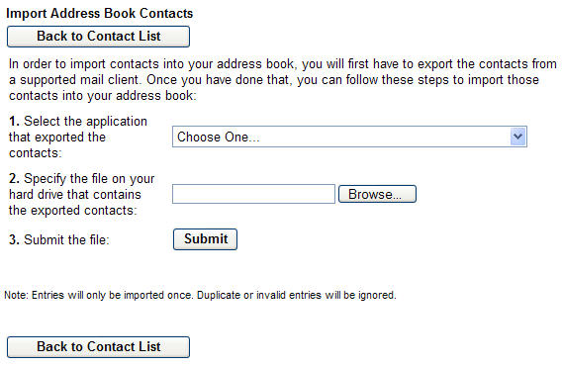

To import the address book:
- Select the application that exported the contacts
- Upload the file from the hard drive that contains the file.
- Click Submit.

Note: Entries will only be imported once. Duplicate or invalid entries will be ignored. If you need assistance with this, contact support.

Editing a Contact
From within Contact Address Book:
- Select the contact you want to edit.
- Click Edit in the upper right corner of the screen.
- Make changes and then click Save in the upper right corner of the screen.

Deleting a Contact
From within Contact Address Book:
- Select the contact and then click Delete.
There is no prompt to confirm deletion. Once deleted, the contact is gone.

Sending Mail to a contact
To send mail to a single contact:
- Highlight the e-mail address from the address book list.
- Click Send To.

To send to multiple contacts:
- Highlight the block of contacts while pressing the Ctrl key. (Command key on Mac)
- Click Send To.

Web Mail Folders
The Navigation Pane displays a list of available folders. From this pane you can easily drag and drop messages and folders. You can also add new folders.

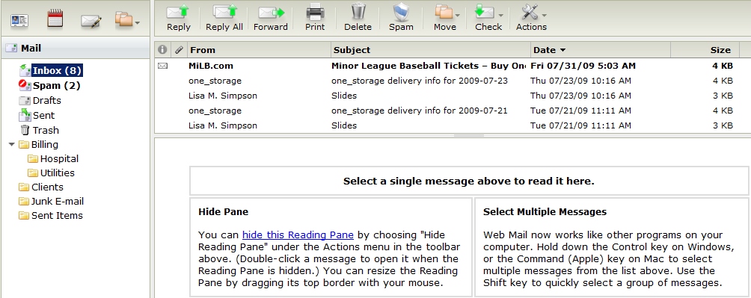

Managing Folders
To select a folder and view the contents, click on the folder’s name. To see sub-folders, click the arrow next to a top-level folder to expand the list.

Creating Folders
To create a top level folder:
- In the Folder Actions menu, select New.
- A new untitled folder will appear.
- Enter the name of the folder and press Enter.

To create a sub-folder:
- Select a top level folder.
- Click Folder Actions to display the menu and select New Subfolder.
- Enter the name of the folder and press Enter.

Renaming a Folder
To rename a sub-folder:
- Select the folder you want to rename.
- Display the Folder Actions menu and click Rename.
- Enter the new name.

Moving a Folder
You can move user-added folders in two ways. Use the Move menu or simply drag the folder to a new position.

To move a folder using the Move menu:
- Select the desired Folder
- In the Folder Actions menu, select Move to display the possible destination folders.
- Select the location.

To move a folder using drag and drop:
- Select the folder to be moved.
- Drag it to the desired folder.
- Drop on the folder by releasing the button.
Note: The folder will indicate whether the location is valid or invalid.

Deleting a Folder
To delete a folder:
- Select the desired folder
- In the Folder Actions menu, click Delete.
- You will be asked to confirm the deletion of this folder. Click OK or click NO to cancel deletion.

Note: The Inbox, Sent, Trash, and Spam folders cannot be renamed or deleted.

Emptying a Folder
To empty a folder:
- Select the desired folder
- In the Folder Actions menu, click Empty Folder.

Note: This action is only available for the Trash and Spam folders.

Changing Folder Properties
You can control behavior of some folders by changing Folder properties.
- Select the folder you want to change.
- Display the Folder Actions menu, and click Properties.

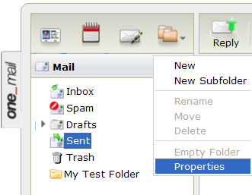

The Folder Properties window is specific to the folder you selected. This one shows the preference choices for the Trash folder.

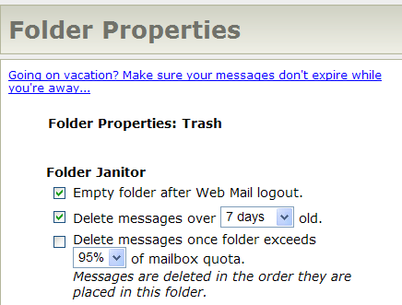

Using Folder Janitor
The Folder Janitor allows you to set automatic e-mail deletion in selected folders.

- Click the options you want to use, then click Save.
- Click OK.

Searching for Messages
To start a simple search:
- Select the desired folder
- In the search field shown below, enter your keyword and click Search.

To refine your search:
- Click the magnifying glass in the Search Field to display fields that allow you to narrow your search.
- Enter the search criteria.
- Click Search.

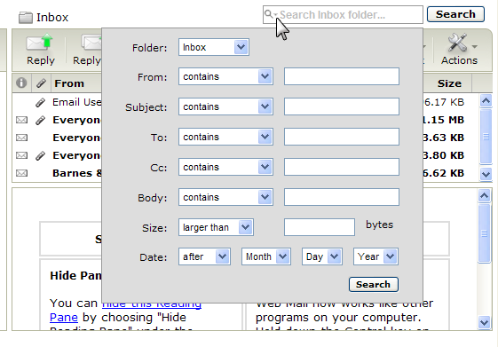

Viewing Web Mail Options
To see Web Mail Options, click the Options link located in the upper right hand corner of the Home page. Depending on the account plan you have, you will see one of the following Options lists.
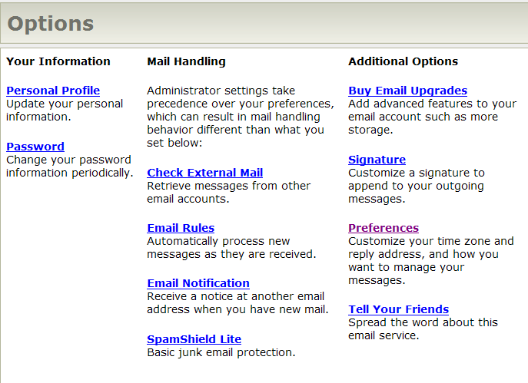

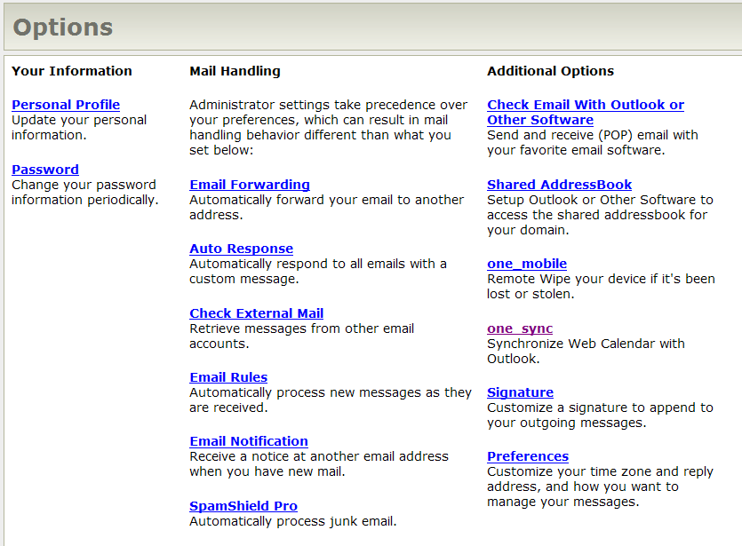

These pages are organized as described in the sections below.

Your Information
Here you can update your personal information and change your password for your account. These options are available for all accounts. You should update this information as needed and change your password regularly.

To update your personal information:
- Click the Personal Profile link.
- Update your information.
- Click Save.
Note: This does not change your display name.

Mail Handling
Options in this section allow you to specify how your mail should be handled.

E-mail Forwarding
You can forward all your e-mail to another e-mail address and optionally keep a copy in this mailbox too.

Choose a forwarding option
- Do not forward any new messages
- Forward all new messages to the e-mail addresses below
- Forward all new messages to the e-mail addresses below and save a copy in this mailbox

Enter one or more e-mail forwarding e-mail addresses separated by commas. For example; you@example.org for a single e-mail address and
you@example.net, bob@example.com for a multiple e-mail addresses entry.

Auto Response
This feature will send a custom message in response to all e-mail that you receive for the duration of time that you specify. Also, your senders will only receive one notification in a 24 hour period. Therefore they can freely e-mail you without constantly receiving your auto response message. Auto Response is turned off by default when you open your Web Mail page.

To turn on Auto Response:
- Select Turn on Auto Response.
- Choose a Start date.
- Choose an End date.
- Enter the subject line for your message.
- Enter your message
- Select Yes if you want to save all incoming mail in your Inbox.
- Select No if you if you want all e-mail to be rejected until the end date specified.

Check External Mail
You can read e-mail from your other accounts (work, home, or remote locations) if your service provider or company provides a POP server.

You must enter the following information for your external account:
- POP Server Hostname
- POP Server Port
- POP Account Username
- POP Account Password

Note: Check External Mail does not support IMAP accounts.

E-mail Rules
E-mail Rules route messages to the designated folders and can be used to approve or block senders based on advanced criteria.
To view e-mail rules:
1. Click the Options link.
2. Click the E-mail rules link.
Note: If you do not have any rules set up there will be none listed on the page.
To create a rule:
- Click Create a New Rule or the New Rule button.
- Name the rule (optional).
- Select the Conditions of the rule.
- Select the Action to perform when executing the rule.
- Click Save.

To edit a rule:
- Next to the e-mail rule you want to edit, click the Edit icon (yellow notepad with a pencil).
- Make the required changes, then click Save.

To Enable/Disable a rule:
- Edit the rule by clicking on the Edit icon (yellow notepad with a pencil)
- Enter a check mark in the Disabled box (located in the upper right corner)
- Make the required changes, then click Save.

To Remove a rule:
- Next to the e-mail rule you want to remove, click the Remove icon (red icon with an X).
- You’ll be asked to confirm that you want to remove the rule. Click OK.
- Click OK.

To Edit the order of the rules:
- Next to the e-mail rule you want to move, click the up or down arrow icon.

E-mail Notification
You can set up your mailbox to notify you when a new e-mail is received. You can receive notification from another mailbox even when you are not logged into your account.

To set up mail notification:
- On the Web Mail home page, click Options.
- Click E-mail Notification.
- In the “Receive a notification of new mail at this address” field, type the address of a second e-mail account.
- Specify a preference for the “Receive no more than one notification every” field. The options are one hour, four hours, or one day.
- Click Save.

SpamShield Pro
SpamShield provides powerful tools to block junk e-mail. You can block senders, hide external images, add approved senders to your list, and with our Pro service, you can insert a SpamShield header in your messages.
To specify SpamShield preferences:
- On the Web Mail home page, click Options.
- Click the SpamShield link to display the page where you can make your choices.

Additional Options
Additional options may vary based on your account type. See your Web Mail administrator with any questions about your account. You may see other services listed here.

Signature
You can append a customized signature to all of your outgoing messages.

Preferences
Set these preferences to customize how your messages are managed:
- Enter the name you would like displayed on the From line
- Select the Reply To address you would like to use for outgoing messages. Most e-mail programs will automatically reply to the Reply to Address if it’s different than the From address.
- Choose the form of forwarded messages. Chose Inline to forward contents with your message, or Attachment to forward content in its entirety.
- Set auto-save to save messages every minute.
- Turn on Auto Complete to get suggested contacts from your Address Book and have the names filled in for you. You simply type a few letters of the contact you want, and you’ll see a list of possible matches from which to select.

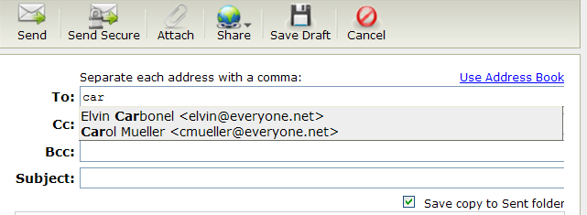

- Choose the text editor for your messages. Rich Text Editor features document styles like a word processor, while the Plain Text Editor creates messages readable by most any e-mail program
- Set the default font for your RichText Editor.
- Save Sent Messages On or Off. Sent messages are saved in your Sent folder, which can be automatically synchronized with other e-mail programs that use IMAP.
- Set your Time Zone, Date Format, and Time Format.
- Choose whether or not to enable new features.
- Set the preferred navigation after moving or deleing a message.

Using Web Calendar
The calendar icon is on the Navigation Pane of the Web Mail home page. Like any other e-mail calendar, you can view a specific date, week, or month. The web calendar can be used for personal and business appointments.

Scheduling Events
When you are the organizer of a meeting or event, you’ll be able to check the free/busy times of your attendees by using the Event Editor in Web Mail.
To schedule an event in Web Mail:
- With the calendar open, select the time period and double-click the left mouse button to open the Event Editor.
- On the Appointment tab, enter the subject or title of the event.
- Click the Attendees tab, and enter names of attendees.
- Click Add after each entry.
- When finished, click Save and Close.
As shown below, free or busy time will be clearly indicated for attendees who share their calendars with you.

Moving Events
If you need to change the time of a meeting or event, you can easily drag it to a new position just as you would in Outlook.
Note: If you are an attendee who needs to reschedule an appointment or meeting, you should always contact the event organizer and ask to have the event moved. You can update your own calendar by moving events. But be aware that the event organizer will not see the change you make.

To reschedule a meeting or appointment:
- Open the calendar and find the event you want to change.  - Select the scheduled event by clicking the left mouse button on the event.  - Drag to the desired location.  When you release the left button, the event expands to its full size.  You can also drag the event to different places on the calendar. | 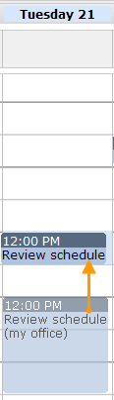

Support
Clicking on Help will provide you with a list of instructions for using Web Mail. If you have any questions, please contact OTEC Communication Company’s Tech Support at 888-232-7930.

